Hughes, Robert. 2001. "THE Poet OF Pastry." Time 158, no. 2: 66.

THE POET OF PASTRY
Wayne Thiebaud offers deep pleasures in the everyday, from pies and cakes to slices of landscape
Where does Wayne Thiebaud fit into modern American painting? You don't have to spend long in his current retrospective at New York City's Whitney Museum of American Art to realize that he fits eccentrically, and that he has been an anomaly for so long that it hardly seems to matter anymore. It seems hardly possible that a painter of this quality should be having his first retrospective in New York when so many lesser talents have been thus honored by the Whitney, but Thiebaud has had to wait a long time to outlive an inbuilt prejudice in Manhattan against California art. He hasn't even been invited to take part in a Whitney Biennial since 1967.

The American artists to whom he is closest are Edward Hopper and his fellow Californian, the late great Richard Diebenkorn; among Europeans, the names Giorgio Morandi, Chardin and Manet are among the first to pop up. But he is also one of those painters who, happily, feel entitled to pick and quote wherever they choose: he does not suffer from the snobbery of influence. "The sublime of Orange Crate art," critic Adam Gopnik writes in his catalog introduction, and one knows just what he means. Thiebaud is one of the few American artists whose ambitions have no Puritan or didactic dimension--he wants to give pleasure but in a serious and considered way, and he does.

The art audience has a way of not taking artists really seriously unless they are in some way "transgressive." To expect transgression from Thiebaud is to miss out on his pictures. He wants to offer people an intelligent pleasure, a spectrum of feeling that isn't snobbish or exclusive--and that acknowledges that there are some kinds of completely valid art, maybe more than we want to think, that go deep just because they look simple. They have concealed themselves behind the pleasure they offer.

On the face of it, Thiebaud, 81, is a Realist. He loves material fact, with a preference for inertia. He started off in the 1960s painting gorgeously lush still lifes of kitsch diner food--everything from hot dogs to angel-food cake and gumballs. Then he turned to painting people, or rather embalming them in his characteristic thick, smooth and (when used to make flesh) slightly rubbery pigment. After moving to San Francisco in the early '70s, he took his eye outside and did cityscapes--those strange, plunging perspectives of the hills and highways of the city, translated into gravity-defying slices, with cars clinging to the asphalt like flies to a wall, as in Apartment Hill, 1980.

They are among the most foreshortened landscapes ever painted, and they have a weird if harmless sense of danger to them, as though all those ticky-tack houses and stern, vertical condos and loops of thruway were about to slide down the canvas and rumple up in heaps at the bottom--fulfilling, in miniature, the prophecy that has always been made for the quake zone. But this prospect feels remote. Thiebaud has never tried to read a sense of Expressionist angst into the California coast.

One of the more recent pictures in this show, California Valley Farm, 1987, is positively goofy. There is a steeply sloping hill with, near the bottom, a tree growing out at a wacky angle. Just above the tree is the farmhouse, which, with its angled porch roof, looks like the profile of a silly face staring in surprise down its triangular nose at the tree. Most recently, after a move out of San Francisco in the mid-'90s, Thiebaud embarked on a series of brightly colored, sharply divided, wildly patterned landscapes of the Sacramento River delta, seen from way up, as though from a plane--for example, River and Farms, 1996.

It is slightly irksome that after all this time, Thiebaud is still thought of by many people as a Pop artist--whatever that name now means. Actually, in relation to his work, it doesn't mean much: only that he was and presumably still is intrigued and delighted by the sight of multiple-produced American food. Not so much the package (like the soup can) as the soup itself, or for that matter the sandwich, the cake or the slice of pie, sitting there in virginal garishness, the coconut icing soft and fluffy as a baby angel's wingpits, under the fluorescent tubes in the glass diner case.

Some people have obstinately wrong ideas about what is multiple and what is unique. A fish or a fruit by an 18th century master like Chardin is thought to be distinct, its presence in the still life making it the only one of its kind. But Nature is a greater mass producer than Culture. The sea is full of sea robins and whiting, all looking the same. The peach tree is laden with identical peaches. So it is with Thiebaud's cakes and pies. He is fascinated by variation within repetition, but he never thinks of repetition as being antipoetic because, in fact, nothing is exactly the same as anything else: two slices of the same pie are never identical.

This point is vividly made in paintings like Thiebaud's Pies, Pies, Pies, 1961. Each of the soft wedges (and how beautifully the squidginess of the oil paint consorts with what it is imitating, the squishiness of the lemon meringue and chocolate!) is very much its own thing. But there are differences of color and shape that save the serried ranks of piedom from monotony, and you are drawn into the small but clear discriminations that make an interesting painting. You end up thanking Thiebaud, in absentia, for reminding you how various and plural the world really is.

What Thiebaud especially loves, however, more than food or the memory of food--and perhaps even more than people, at least from the pictorial point of view--is craft. He is a terrific craftsman. Whatever he asks paint to do, it will (almost invariably) do, and come up smiling and looking effortless after it's done. With a very few exceptions, every picture in this show displays a sort of seraphic ease with itself, an unfussed wholeness. The surface is dense, creamy and unctuous, yet it never looks dragged or displays the laborious appearance of palette-knife work. It is painted all the way, and it invariably looks as though it was put on alla prima, without glazing or reworking.

You see what he's aiming for: the sort of one-shot, spot-on accuracy that Manet displayed when he painted his single stalk of asparagus with what looks like a single brushstroke. Except that Thiebaud has a way of punching up the effect with sharp lines and rainbow profiles of complementary color, a green or a purple, that pulse like halos and throw the whole form into relief. He isn't being hit-or-miss. He is, on the contrary, being intensely thoughtful. The arrays of pie slices or cake stands become Utopian: soft but strict geometry. (No wonder the Pop artist Thiebaud liked best was Claes Oldenburg.) One of the dictators of classical French banquet cooking in the early 19th century, Marie-Antoine Careme, was once asked to name the main arts of humankind. He reeled them off, finishing with "architecture--of which the principal branch is la patisserie." Thiebaud might have agreed.

PHOTO (COLOR): PIES, PIES, PIES, 1961
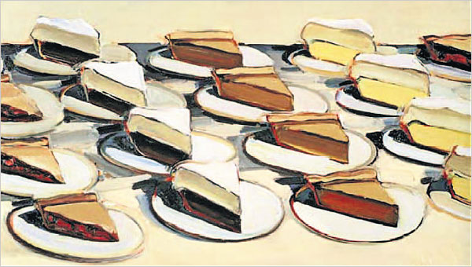
PHOTO (COLOR): THE ARTIST, 1985
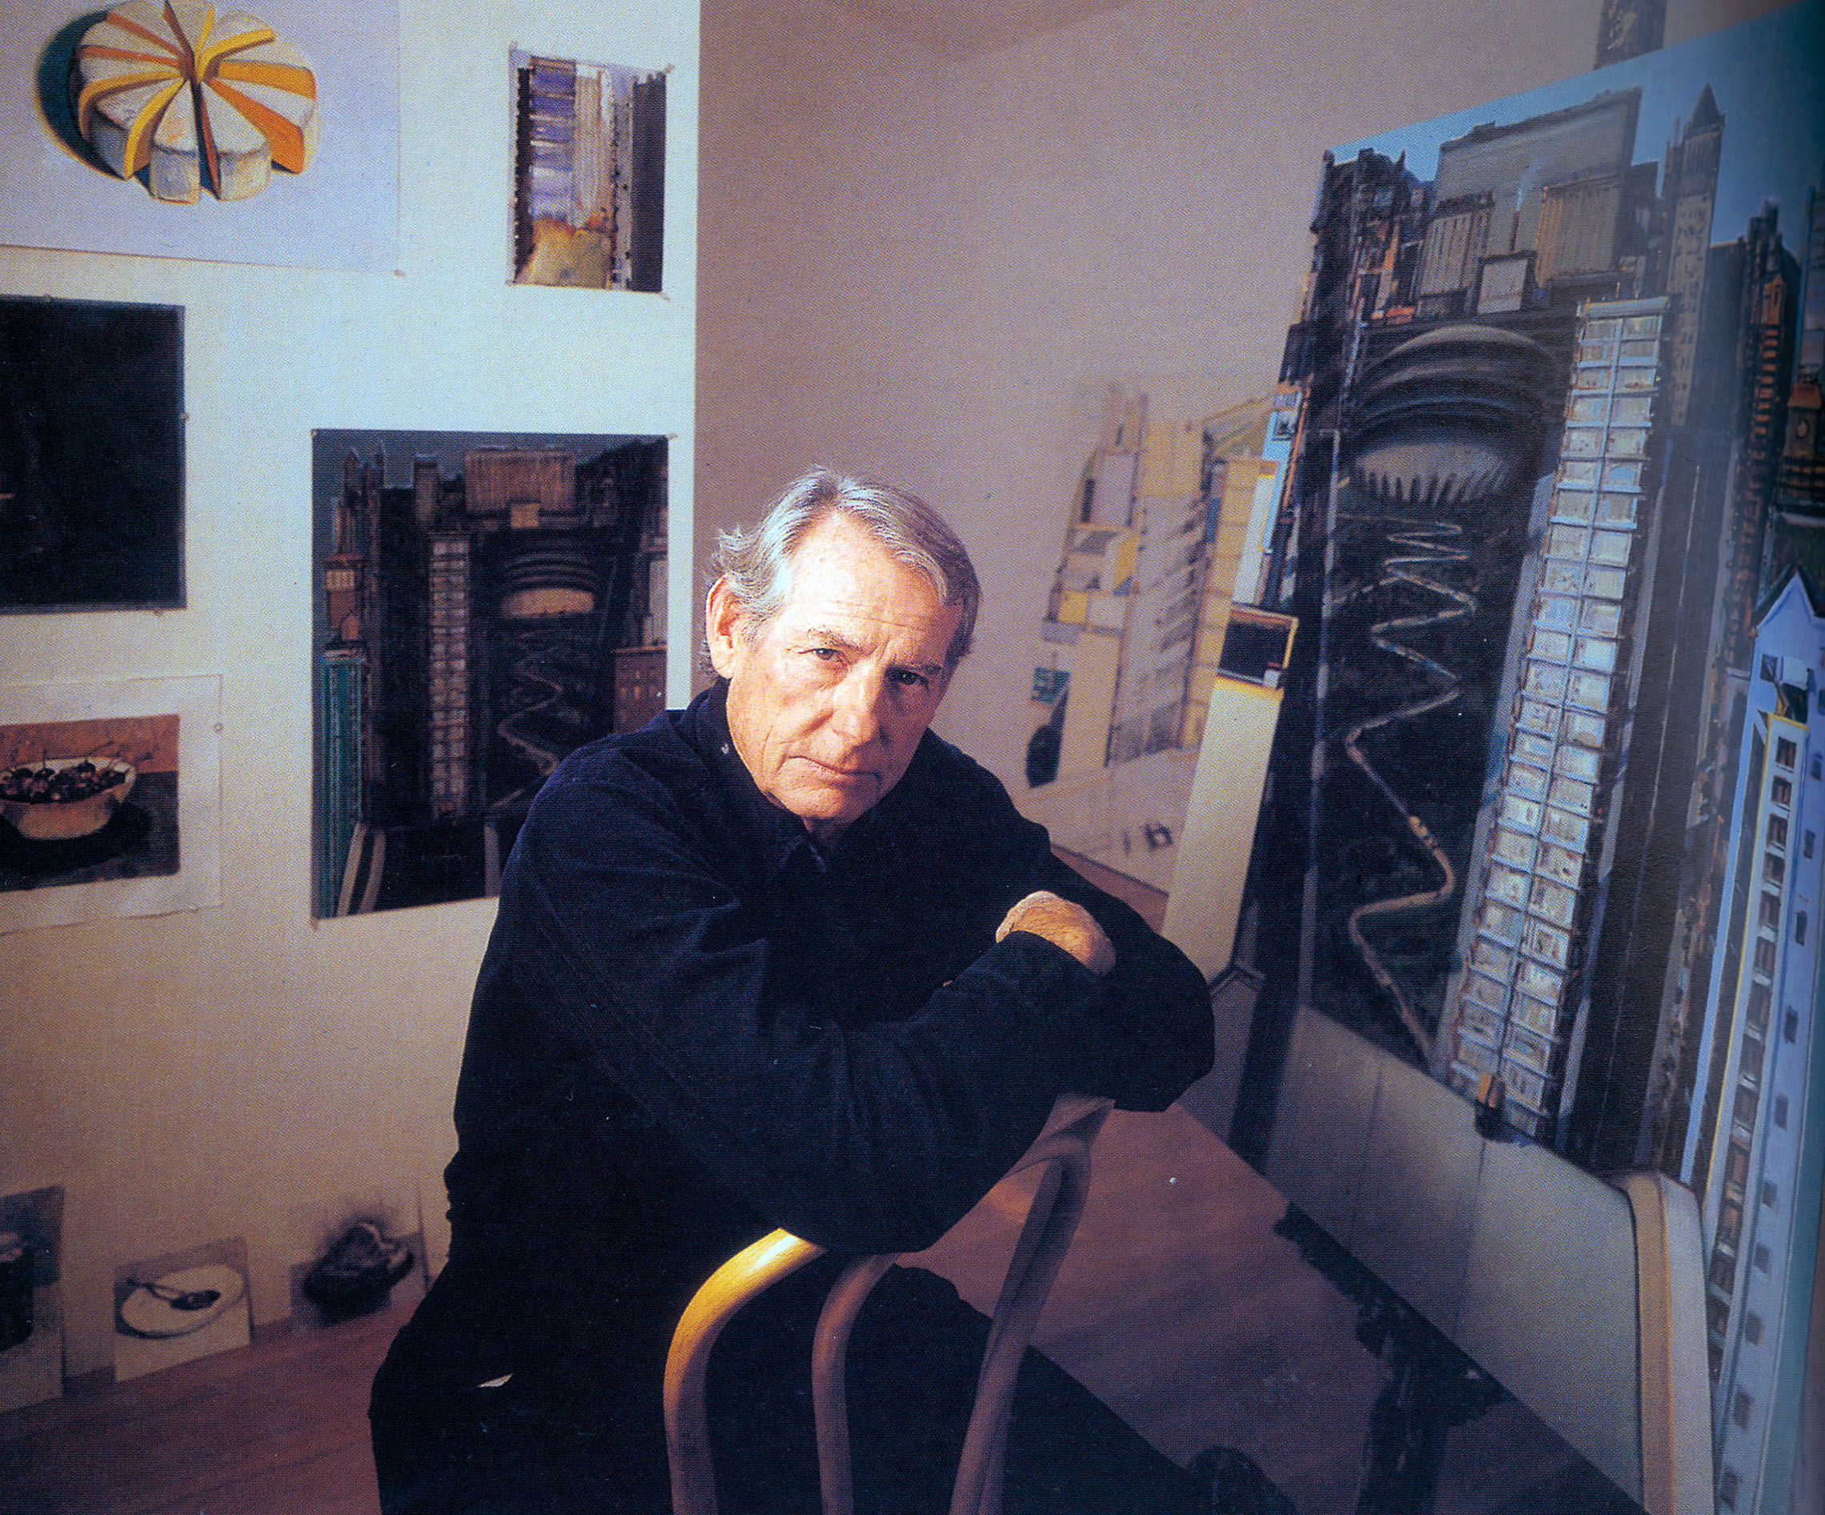
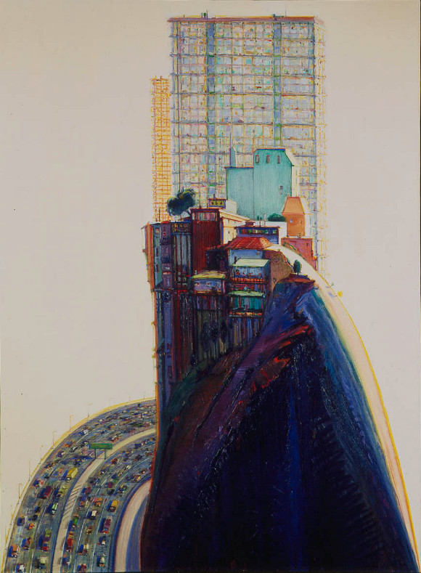
PHOTO (COLOR): APARTMENT HILL, 1980

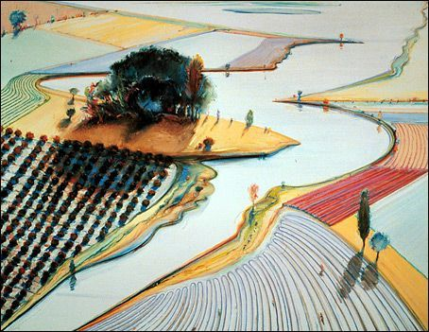
PHOTO (COLOR): Waterland, 1996

~~~~~~~~
By Robert Hughes

© Time Inc., 2001. All rights reserved. No part of this material may be duplicated or redisseminated without permission.

Back

